Monday
9:30a- Amazing Abs/ Ivy
11:00a- Zumba/Lorena
4:30p-BARRE/ Audra
5:30p-BodyPump/Manda/Bridgette
6:30p-Yogaflow/Audra

Tuesday
9:30a-Bodypump/ Stevens
10:30a-Yogaflow Express/Ivy 11:00a-SilverSneakers® Classic/ Brooke
4:30p-BodyPump/Bridgette
5:30p-Cycle Party/ Bekah
6:00p-Kickboxing/ Jess
***NEW TIME***

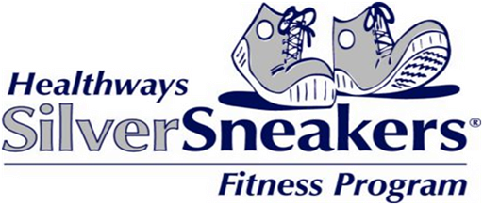

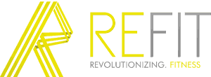

June
Kinetix Group Fitness Schedule

NEW CLASSES
11:00a: SilverSneakers BOOM
Sat 10:30a: REFIT DANCE PARTY

M,W,F 5:30a: Spring Bootcamp w/Bridgette
$18/class drop in fee

Wednesday
8:30a- Booty Bands/ Ivy
9:30a- Zumba/Zumba Step/Lorena
9:30a-Cycle Party/Ivy
11:00a-SilverSneakers® Classic/ Brooke
4:30pm Zumba/Michelle
5:30p-BodyPump/Gina/Beth

Thursday
9:30a-BodyPump/Stevens
10:30a-Yogaflow Express/Ivy
11:00a- SilverSneakers® BOOM Lorena
***NEW CLASS***
4:30p-BodyPump/Manda/Ivy
5:30p-Yogaflow/Audra
5:30p-SPRINT/ Melissa
6:30p-GRIT Strength/ Manda

Friday
9:00a-BARRE/ Jae
11:00a- Fit Fun Fifty +/ Lorena
5:30p-REFIT DANCE/ Ryan

Saturday
8:30a-Cycle Party/ Brooke/Ivy
9:30a-BodyPump/ Gina
10:00a-TotalFit/ Whitney
10:30a- REFIT DANCE/ Ryan
***NEW CLASS***

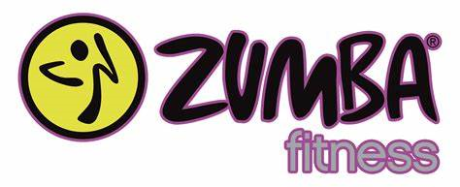

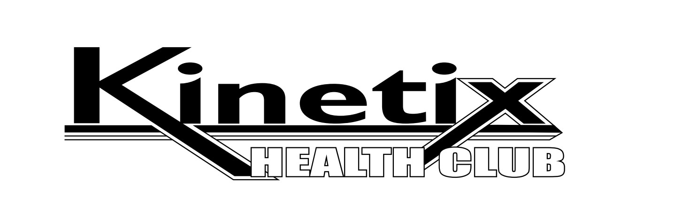
Membership Fees

Fort Hill and Forest Locations
No Enrollment Fee
$24.99 / mo. – Active adult (65 yrs. & older)
$24.99 / mo. –Young adult (18-25 yrs.)
$34.99 / mo. – Membership for one person
$59.99 / mo. – Member and Spouse
$74.99 / mo. – Family Membership

Forest Only Location
No Enrollment Fee
$19.99 / mo. – Active adult (65 yrs. & older)
$24.99 / mo. – Membership for one person
$44.99 / mo. – Member and Spouse
$54.99 / mo. – Family membership

NO LONG TERM CONTRACT!
Month to Month Memberships
** Family membership – Children under 17 years of age must be accompanied by an adult.

*NOW ACCEPTING SILVERSNEAKERS INSURANCE

MEMBERSHIP ADVANTAGES
We have state of the art cardio equipment. No need to worry about waiting or time limits. We have over 75 cardio machines with built in TVs. Use our weight machines that automatically count reps and monitor your time. We also have commercial grade free weights and equipment such as bench presses, squat racks, dead lift racks, dumbbells, kettle bells, medicine balls, and more! Both facilities have locker rooms and showers.

24-HOUR ACCESS AT BOTH LOCATIONS

The Fort Avenue location also offers:
Access to group fitness classes
Hydro massage beds
Tanning beds
FREE childcare while you work out as scheduled

Personal Training

Great Trainers- Great Rates-Great Results.
Payment Arrangements Available.
Ask us for details

Boot Camps – Meet twice a week for 6 weeks with a trainer for 45 - 60 minutes. Get ready to get busy!

CLASS DESCRIPTIONS

BARRE- using a ballet barre, WEIGHTS, AND BANDS you will receive a targeted, full body, resistance workout. Get ready to sweat!!

BODYPUMP: THE ORIGINAL BARBELL CLASS THAT STRENGTHENS YOUR ENTIRE BODY. IT’S A ONE HOUR WORKOUT THAT CHALLENGES ALL OF YOUR MAJOR MUSCLE GROUPS.

BOOTY BANDS- Lift and tone your back side with
resistance bands!

BOOM: A higher intensity dance workout class that improves cardio endurance and burns calories. MOVE is all about breaking a sweat and having fun. The class focuses on cardio endurance by starting with simple dance moves then building into more complex sequences, bringing you a great cardio workout.

CYCLE PARTY: CYCLE WITH SOME HIP HOP FLAVA MOVEMENTS. IT’S A PARTY ON THE BIKE!

FIT, FUN & FIFTY+: DESIGNED FOR THE 50 AND OLDER FITNESS FANATIC, THIS CLASS COMBINES BASIC WEIGHT TRAINING AND CARDIO THAT WILL INCREASE BONE DENSITY, DECREASE RISK OF OSTEOPOROSIS, INCREASE METABOLIC RATE WHILE DECREASING BODY FAT, INCREASE STRENGTH AND ENDURANCE, AND PREVENT INJURIES. WE INCORPORATE CARDIO, WEIGHTS, COORDINATION AND BALANCE.

REFIT DANCE: REFIT® DANCE FITNESS IS AN EASY-TO-FOLLOW, ATHLETIC-STYLE DANCE WORKOUT DESIGNED FOR ANY ONE, EVERY BODY. NO EXPERIENCE NECESSARY. COME SWEAT, LAUGH, BURN A LOT OF CALORIES, AND TRULY ENJOY YOUR FITNESS REVOLUTION!

SILVERSNEAKERS® CLASSIC: HAVE FUN AND MOVE TO THE MUSIC THROUGH A VARIETY OF EXERCISES DESIGNED TO INCREASE MUSCULAR STRENGTH, RANGE OF MOTION, AND ACTIVITIES FOR DAILY LIVING.

SILVERSNEAKERS CIRCUIT- MORE ADVANCED AND MORE CARDIO THAN THE SILVERSNEAKER CLASSIC

SPRINT: 30 min Cycle class(HIIT) HIGH INTENSITY Interval Training to achieve fast results!

TotalFit: a FULL BODY cROSS TRAINING sTYLE WORKOUT FOCUSED ON TRAINING THE BODY MIND AND SPIRIT. fOR ALL LEVELS WHO WANT TO TRAIN TO DEVELOP their OVERALL HEALTH!

YOGAFLOW: A WORKOUT THAT BUILDS FLEXIBILITY AND STRENGTH. THIS CLASS LEAVES YOU FEELING CENTERED AND CALM. FOR ALL LEVELS

¹⁹ Or do you not know that your body is a temple of the Holy Spirit within you, whom you have from God? You are not your own, ²⁰ for you were bought with a price. So glorify God in your body.
1 CORINTHIANS 6:19-20

Group Fitness
Schedule
June 2021

+

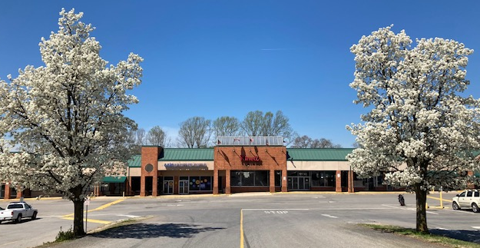

LOCALLY OWNED AND FAMILY OPERATED
HOURS OF STAFFED OPERATION:
FORT HILL VILLAGE

MONDAY–THURSDAY: 5AM-10PM
FRIDAY: 5AM-8PM
SATURDAY: 8AM-5PM
SUNDAY: 1PM-5PM

24-HOUR ACCESS

DAYTIME CHILDCARE HOURS
MONDAY - SATURDAY
9AM TO NOON

EVENING CHILDCARE HOURS
MONDAY – FRIDAY: 4PM-7PM

ke us on Faceboo
Lynchburg Forest Express

Fort Hill Village Cavalier Shopping Ctr.
6015 Fort Ave. Suite 24 1208 Perrowville Rd.
Lynchburg, VA 24502 Forest, VA 24551
434-239-0015 434-525-0015

